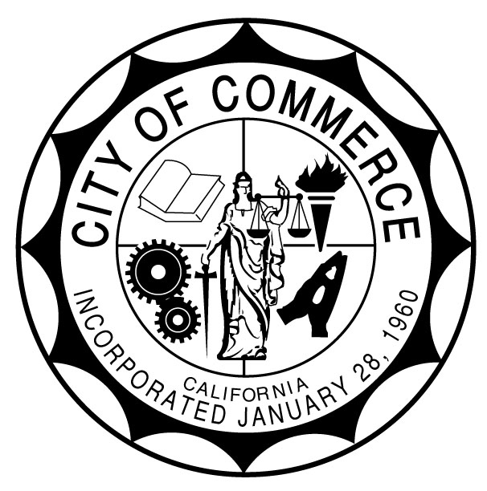
CITY OF COMMERCE
AGENDA REPORT

TO: Honorable City Council

FROM: City Manager

SUBJECT: Resolution Reciting the Facts and Results of the General Municipal Election Held on November 5, 2024

Meeting Date: December 10, 2024

RECOMMENDATION

It is recommended that the City Council approve a Resolution ratifying the results of the election held on November 5, 2024.

BACKGROUND
The City Council adopted Resolution 2024-25, officially calling for a General Municipal Election on Tuesday, November 5, 2024. This election was held to fill two City Council seats, each for a full four-year term. Additionally, the City Council approved Resolution 2024-26, requesting specific election-related services from the County.
The County completed and certified the election results on December 3, 2024. Attached are the County’s Certificate of Election Results and a Resolution reciting the election outcomes for ratification by the Commerce City Council.
Hugo Argumedo and Oralia Rebollo were elected to the City Council, having received the highest number of votes for the full term of four years.
Once the City Council adopts the Resolution ratifying the election results, certificates of election will be prepared and delivered promptly.

FISCAL IMPACT

There is no cost associated with this action. The cost for the November 5, 2024, General Election was estimated at $35,000 and was included in the City’s Fiscal Year 2024-2025 Budget.

Respectfully submitted by: Ernie Hernandez, City Manager
Recommended by: Lena Shumway, Director of Administrative Services and City Clerk
Reviewed by: Noel Tapia, City Attorney

Attachment:

- Resolution
- Certificate of Election

